香港航空青年團  HONG KONG AIR CADET CORPS  Sung Wong Toi Road, Kowloon, Hong Kong  Tel 852 2712 8900 Fax 852 2715 6944 | 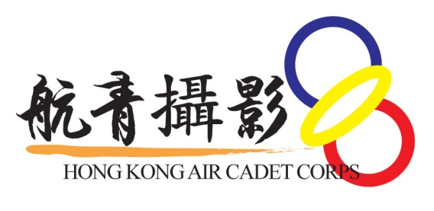
From : Photo Flight | To : OCs Squadron
Email : enquiry@hkacc-photo.org | Cc : DCO Ops, OC Ops Gp, DCO Trg, OC Trg Gp, OC Wg, DCO SD&S, OC Sp Svc Wg
Ref : Photo/2021/003 | Date : 19 March, 2021

Portrait Photo Day
Please be informed that cadet members who have applied to join the portrait photo day are listed in Appendix 1.

Details of the activity are as follows:

Date and time: 1330-1730 hrs on Sunday, 21 March 2021
Venue: HQ Workshop
Dress Code: No.2A(Long sleeved) service dress with ribbons

All members entering HQ workshop are required to record their visit with LeaveHomeSafe (安心出行) Apps or fill in the forms provided in HQ workshop

Should you have any enquiries, please contact Sergeant Instructor LAU K H Edward at 9811-4254.

Kay LI
Flt Lt
OC Photo Flight

Appendix 1
Time Slot | Sqn | Name
1330-1400 | 104 | YEUNG Jin-hei
 | 506 | FAN Sheung-wang
 | 506 | HUI Chun-hei, Aldis
1400-1430 | 302 | MAU Chung-hin
 | 304 | AU-YEUNG Ching-long
 | 308 | LEUNG Tsz Ching
 | 313 | LAM Hui-ching
1430-1500 | 102 | SZE Hiu-tong
 | 308 | CHOI Ka-lok Vincent
 | 313 | CHUNG Ka-hei
 | 313 | CHEUNG Ka-man
1500-1530 | C | WONG Hoi-lam
 | 401 | CHEUNG Lai-ho
 | 405 | YIP Chak-leung
 | 406 | NG Mei-sze
1700-1730 | C | PANG Chi-lik
 |  | LEUNG Hei-chi
 |  | CHENG Yung-ki Giselle

